LSOA Zone | % Population Aged 0-4
23 | 3
25 | 4
30 | 6
31 | 6
98 | 7
64 | 7
69 | 7
59 | 8
72 | 9
99 | 11
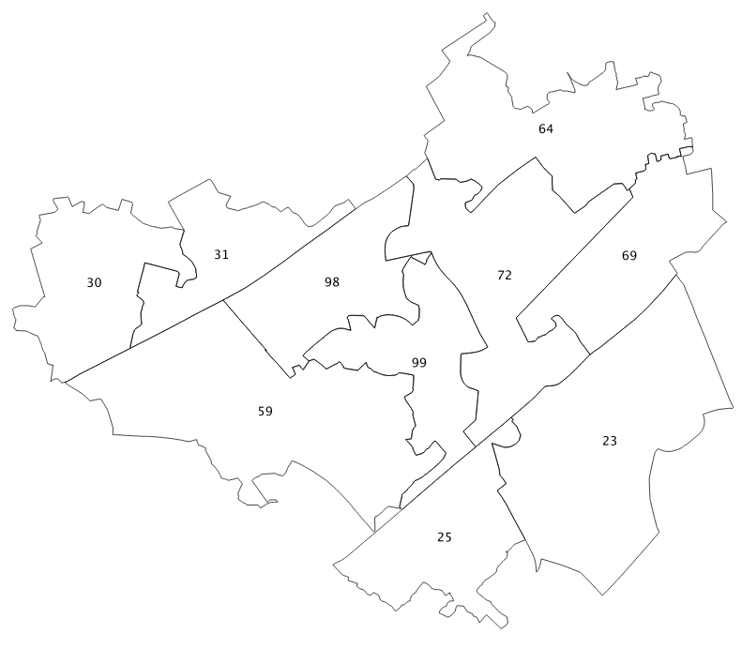
http://www.nickbearman.me.uk/twe/wp-content/uploads/2015/01/basics-spatial-data.pdf
Using the values in the table, colour in the LSOAs in this part of Liverpool according to the percent of population ages 0 - 4 in 2011. Also remember to indicate in the table which colours represent which values.

