Supplementary information for Bearman et al (2012) Using Sound to Represent Uncertainty in UKCP09 Data with Google Maps API
The following flow charts show how the program code links together, and should be read in conjunction with the associated academic paper. People interested in the technical details should also read “Bearman N. Appleton K. In press. Using Google Maps to collect spatial responses in a survey environment Area”.
The programming code used is available from http://hdl.handle.net/10672/286. The flow charts below show how the program operates.
Process

Input / Output

Process with further detail available in another flowchart

Key

Figure 1. Key for the following flow charts.

Introduction
Computer Based Evaluation

Wait for all participants to finish

Discussion Session

Participants Arrive
Consent Form
Evaluation
Figure 2. Flow chart of the overall evaluation process.

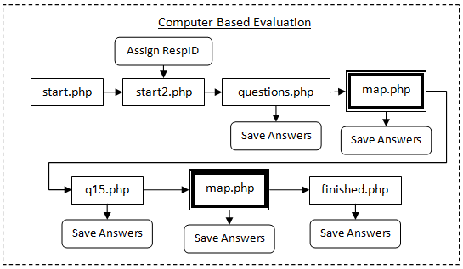
Figure 3. The flow of the computer based evaluation, operated by the participants on an individual basis. The individual PHP files are available with the code and a further flow diagram is provided for map.php.

Yes

Map.php

Load

RespID, Method, Data, Map

Create maps & legends as relevant

Pre-load sounds

Sound files

Wait for mouse move

On MouseMove

Cell Value
Is cell different to one that was previously selected?

Lookup required sound

Play Sound
Wait for next MouseMove

If mouse is clicked

Record Location and mark on map

Finish

If on Map3, then load q15.php

If on Map1/2/4/5, then load next map

If on Map6, then load finished.php

Stop all sounds

Sound Needed

On MouseMove

Save selected area

Save

A
B
C
D
Figure 4. Flow charts for the main file in the evaluation, map.php. ‘A’ shows the process of loading the maps and pre-loading the sound files. ‘B’ shows the process for playing the sound when the mouse is moved over the map. ‘C’ is the process for recording the selected area. ‘D’ is the process when the user has finished the task, and moves on to the next map or ends the evaluation.

